**Assignment 7:**

**Assignment: Understanding Spatial Reference, Georeferencing, and Projection**

### **Aim:** To understand the theory behind assigning a spatial reference (georeference) and projection to a given Toposheet or map.

### **Georeferencing**

#### **1. Spatial Reference System (SRS)**

An SRS is a framework that defines spatial relationships and coordinates, ensuring data aligns correctly with real-world locations.

#### **2. What is Georeferencing?**

Georeferencing is the process of assigning spatial coordinates to a raster image or map, aligning it with an established coordinate system.

#### **3. Ground Control Points (GCPs)**

GCPs are specific, known locations on the map that help establish a relationship between the map and the chosen SRS, ensuring accuracy.

#### **4. Transformation**

Transformation involves converting coordinates from one SRS to another, allowing for the integration of spatial data from different sources.

### **Projection**

#### **1. What is a Map Projection?**

A map projection is a mathematical method for transforming the Earth's spherical coordinates (latitude and longitude) into planar coordinates (x and y) for mapping purposes.

#### **2. Types of Map Projections**

Different projection types serve different mapping needs:

* **Cylindrical Projections** – Common for world maps, useful for navigation.
* **Conic Projections** – Best for regional mapping with minimal distortion.
* **Azimuthal Projections** – Ideal for mapping polar regions.

#### **3. Coordinate Reference System (CRS)**

A CRS consists of:

* A **map projection**
* A **datum** (a reference model of Earth’s shape)
* A **unit of measurement** This system ensures that spatial data is accurately aligned for analysis and visualization.

### **Key Concepts**

#### **1. Datum**

A datum is a reference point or model that defines the relationship between the Earth's surface and a map projection, ensuring consistency in spatial data.

#### **2. Ellipsoid**

An ellipsoid is a mathematical representation of the Earth's shape used as a reference for different projections.

#### **3. Geographic Coordinate System (GCS)**

The GCS is a system that defines locations on the Earth using latitude and longitude, providing a universal framework for geospatial mapping.

**Result :**

**Step 1:** Select add layer and vector layer

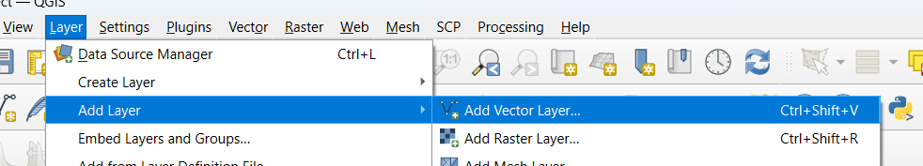

|  |  |
| --- | --- |
| **Step 2:** Select vector file | Step 3 : Add the vector file |
| Step 4: after adding vector file show this map | Step 5: select georeferencing |

|  |  |
| --- | --- |
| **Step 6:** after opening georeferencing select the vector file | **Step 7:** select the raster file |
| **Step 8:** after opening raster file this window will show. | Step 9: Then select the ok |
| Step 10: then select the transformation setting. | Step 11: Run it then show successfully msg |

|  |  |
| --- | --- |
| **Step 12:**  After successfully georeferenceing this map will show | Step 13: open the projection and select run |
| Step 14: projection will be competed | Step 15: finally output |